First Annual CCBA Up The Chester River Pursuit Race
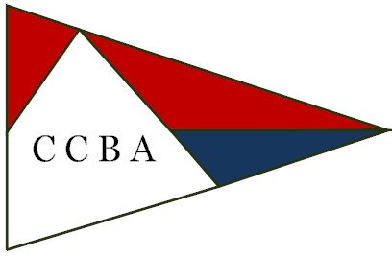

Up the Chester River Pursuit Race 2026
June 18,2026

The Plan:
Leverage the Rock Hall Yacht Club’s Down River Race on Friday, June 19 with an Up (the Chester) River leg the day before, June 18th, starting near RHYC.
Start at the LC buoy off the Lankford Creek on the Chester River head up to the Chester River Yacht & Country Club, Red Channel Marker #40. Course length is 13 miles (slight change from chart below).
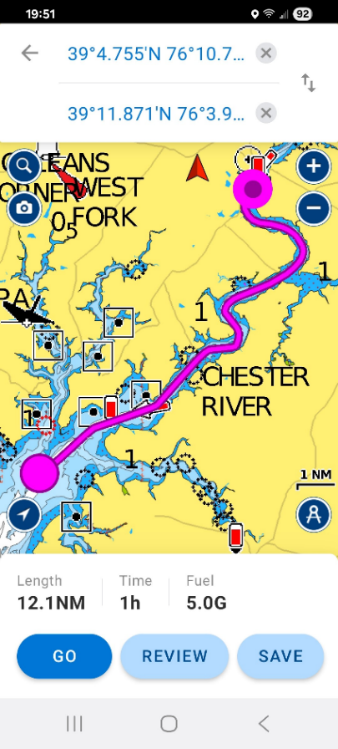
Timing:
First boat (the slowest one); Start at 0900 on Thursday, June 18th at the “LC” buoy.
Informal start - must be within 15 feet of "LC" Buoy at start time.
Informal finish - must end within 15 feet of the Red Buoy off CRYCC
 |  |  |  | Course in
 |  |  |  | N/M
 | Boat | Start Time | PHRF # | LC to #40
First to start | Marshall 15 Sandpiper | 9:00:00 | 378 | 13
 | Menger 19 | 9:09:45 | 369 | 13
slow | Legnos Mystic 20 | 9:12:07 | 315 | 13
to | Marshall 18 Sanderling | 9:16:15 | 310 | 13
less slow | Marshall 22 | 9:17:30 | 291 | 13
 | Wittholz Prudence 25 | 9:29:00 | 280 | 13
Last to start | Americat 22 | 9:31:00 | 235 | 13

Meals:
Wednesday June 17: Rich has arranged for trailer launch, anchorage and dinner at the RHYC. He’ll need a head count by June 15.
Thursday June 18: dinner and awards at CRYCC. 6pm. We have reservations for 30 in a separate space. Bob will need a head count for the Club Manager, Jerren by June 15.
Even if you don’t race, please come to dinner at CRYCC. Order off the regular club menu and with a cash bar.
Contact the Dockmaster, Bruce Hunt, brucehunt@outlook.com,202-664-0994Dave Hobson
dfhobson23@gmail.com
703-909-7590 to arrange for an overnight slip.

Current RSVPs:
Skipper will race will dine guest total
Bob Corney Y Y 2
Fred Sherriff y Y 2
Rich McLaughlin ? Y ?
Phil Livingston Y Y ?
Frank Newton Y Y 2
Jim Stevenson Y ?
John Henderson* ? Y 2
Digger Y Y 2
Butch Miller Y Y 1/2?

*John is looking for a crew spot on a Marshall 18.

Any questions contact Bob rbcorney3@gmail.com 856-979-4314

