CCBA Long Cruise 2025 - “To the Islands”
Butch Miller

This year’s destination, as requested by Curlew’s crew, was to the islands of Smith and Tangier in the central Chesapeake Bay. They both lie approx. 10NM offshore from Crisfield, MD but in different states. Smith island in Maryland is the larger of the two having three towns while the smaller Tangier in Virginia has one. Most of the area denoted to each is mostly underwater or marsh.

Our original plan was to sail to and stay or anchor out at each island but a reconnaissance mission by Scout One Feather, Phil Livingston revealed that, since our last visit, there are no longer any transient facilities or decent anchorages within reasonable rowing distance. The plan changed to using Crisfield as a home base and ferry across but the trip to Smith was stymied as the ferry only runs on weekends starting after Labor Day. So, Smith was out altogether. Marc on Wanderer had intended to forgo the islands, opting to modify his itinerary to visit a friend in Reedville, VA. on the Western Shore, but just as far south. Marc’s comments about his adventure are addended to each day.

The intrepid fleet: Curlew - Kate Grinberg and Tim Kallman, Lark – Butch Miller,
Patriot – Phil Livingston, Tigger – Frank Newton and Wanderer – Marc Cruder.

Day One – Sunday, Sept. 14 – Slaughter creek on the Little Choptank river, 30NM for most.
Lark and Tigger departed Island View Marina on Kent Island at 9:30am into a dead calm, sunny morning under engine, perfect motoring weather. We arrived at Chapel Cove on Slaughter creek at around 4 to find Patriot from Oxford at anchor. Curlew from the West River arrived shortly thereafter to join us in the raft-up. For dinner, the five of us hopped aboard the Tigger Taxi to shuttle to one of the two local spots on the creek, Boats and Hose restaurant (that’s hose like in garden, not another meaning). B&H is a local, first responder-themed former grocery/hardware store with good food and great service. The last time we were there it was packed and short staffed. One of the customers actually got up from her table and helped serve us. That’s the kind of place it is. Wanderer from the West River tied up to their bulkhead just in time to join us. At some point during dinner, it was decided to make another itinerary adjustment due to the forecasted gale and rain on Tuesday. We would skip Monday’s stop at Solomons and head directly for Crisfield so as not to get trapped in Solomons and miss our ferry reservations. The forecast for Monday was a ramp-up to the coming gale, so reefs were put in before settling-in for the night on separate hooks. The anchorage was calm and buggy.

Day Two – Monday, Sept. 15 – Crisfield off of Tangier Sound, Southward 50NM
Awoke to clouds and 65*, NE 10-15 and building. Anchor up at 7:30am
As we made our way South along the eastern shore past Hooper’s, Bloodsworth and South Marsh islands, the fleet separated into two groups Lark and Patriot, then Curlew and Tigger. The latter caught the former after the former turned into Kedges Strait and into head winds, later reported by others to be 20-30kts, gusts to 40+ (streaks on the water) and 4-5’ seas. Lark powered up the engine to avoid the leeward Solomons Lump shoal light. Shortly thereafter, Phil saw my centerboard from the side, and I saw his from his stern. All sails dropped after that. It was a long motor into Crisfield. One of those where you can see the town but have to run past it along the shore and around a point before turning towards the town then most of another hour to get reach it.

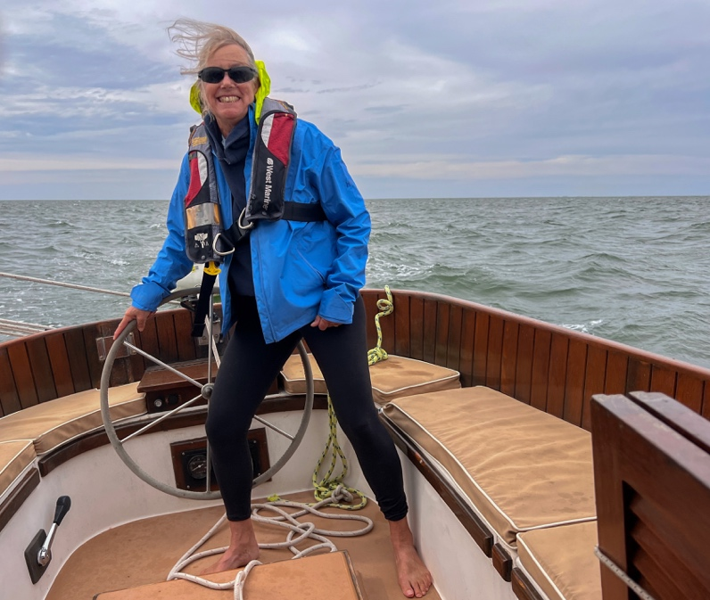
“Breezin Up” - Tim Kallman

We arrived at Somer’s Cove Marina around 6:30pm after a difficult 11hour day, stirred but not shaken. Docking was a chore with our cat-headed rigs in the wind. No dinner, cockpit cocktails, cheese and crackers on Curlew was all we were up for. The marina is huge having 500 or so slips, 50 of which were taken up by members of a trawler group having a weeklong gathering. I think that group has more gray hair than ours. But no early to bed that night. Sadly, to say but one of the trawler group went missing in the gated marina. She was assumed to have fallen into the water on the way back to her boat, so the search was on. Dozens of people were out in the occasional drizzle with their flashlights and EMTs with their big lights, all calling her name. Helicopters and divers joined the search but had no luck that night. She was found on land the next afternoon on. Tragic.

Marc: “Wanderer headed southward and made good time under favorable wind and tide with a single reef, but experienced the same building seas. I decided to quit 5 miles short of Great Wicomico Light which is the entrance to Reedville, doused sail and ducked into the well-marked breakwater at Smith Point on the south side of the Potomac at about 4:30 pm, into the Little Wicomico River. There amongst all the leased bottom engaged in aquaculture, I found a lee just past the #14 red nun and dropped anchor. Dark and Stormies followed by some Hormel Chili by oil lamp light completed the evening fare, but not before a very nice sunset ahead of the pending stormy night and gale force winds out on the Bay.”

Day 3 – Tuesday, Sept 16 – Lay day in Crisfield
The gale arrived with rain and lightning. The crews enjoyed a late breakfast up the street at Gordon’s Confectionary, a quant waterman’s hang-out last remodeled (and scrubbed) in 1954. The only confections are on the Hostess rack. Open at 4am, they serve breakfast all day and lunch fare. The rest of the stormy day was spent mostly in the cabin and chatting in the marina office. Dinner was had, after a walk in the rain, at the Water’s Edge Café, a small simple, restaurant in the west side of town. The food was good especially the Terrible Tuesday Chicken Dinner, most of a bird seasoned and deep fried, eight pieces. To our dismay, it was BYOB. The walk back in the deluge was fun until I found the paper with the gate combination had melted. I was stuck outside the gate and had to wait for security to let me in. Back at the boat, I shed my soaked pants in the cabin and tossed them out into the cockpit. The marina laundry became a very popular spot the next morning.

Marc: “Wanderer had a peaceful night anchored with lots of rain but no lightning or thunder. It was corned beef hash and hard-boiled eggs for breakfast, before calling Smith Point Marina to see if they had any transient slips. I got underway under power to double back to the marina, only to find it was less protected than the anchorage in the lee I had found. Just when I was ready to head back to the anchorage, my friend from Reedville showed up, so we went to lunch at Leadbelly's, the only restaurant open for business in Reedville. It was across Cockrell Creek from where the Menhaden fleet tied up. The car ride to and from Smith Point Marina took in most of what there was to see in Reedville, so not a wasted trip. Once back at the marina, Wanderer made her way back to the peaceful anchorage with the storm blowing all around. Light snacks for dinner after a mid-afternoon lunch in Reedville.

Day 4 – Wednesday, Sept 17 – Ferry to Tangier Island
After another late breakfast at Gordon’s, we walked to the ferry for the noon boarding. The ride to the island was just over an hour for the fifteen of us on the three hundred passenger vessel. Tangier is another victim of changing times, sea level rise and land subsidence like Smith Island. Once a thriving town based on crabs and oysters, it’s failing as harvests dwindle, the waterman age out and the young ones pursue occupations off the island. Unlike Smith there is a K-12 school of 30 or so students. It had one graduate last year. The Smith Island kids take the mail boat to Crisfield then a bus to school. We had a hot dog and ice cream at Four Brothers Crab House and Ice Cream Deck. No inside tables. Of course, our roving ambassador “Hi, I’m Jersey Frank, who are you?” Newton found a couple of new friends, a spunky older woman driving a golf cart in a striped pink seersucker jump suit and sweater, and the mate on the ferry who grew up in Jersey. After arriving back in Crisfield, we took a drizzly walk to dinner in town at Chesapeake Seafood and Steak. BYOB again, but we came prepared. More rain that night.

Marc: “With wind from the south, hazy visibility at best and the chance of more rain, a lay day at anchor was the plan for Wanderer. Skies did clear substantially after intermittent rain all day, which made for a good "Boat Appreciation Day" cleaning and, fixing odds and ends. Dinner was all out, including Zatarain's Red Beans and Rice with smoked sausage to end the day prepared to get underway under sail for Reedville in the morning.”

Day 5 – Thursday, Sept 18 – Tedious Creek off Fishing Bay between the Honga and the Nanticoke rivers, Northward 22NM. Cloudy, wet, N 10-12-0
Gordon’s at 7am. Says Barbra the waitress from behind the counter “Ben’s cooking. Don’t get the sausage”. It’s that kind of place. Fueled up then shoved off around 10am. Nice sail north for a while with the reef still rigged from Monday. Tacked up Tangier Sound until just after noon then motor sailed. Dropped sail when the sun popped out around 3:30pm just east of Bloodsworth Island. Arrived at Tedious Creek around 6pm and anchored in 3 ½’ of soft mud at low tide which is average throughout the creek. There are dozens of crab boat mooring poles but only a few boats at private piers these days. We enjoyed our first cockpit cocktail raft-up of the trip. Curlew split off which was a good thing as the remaining three-boat raft drug anchor for a short way overnight. No problem.

Marc: “With the wind easing around to the Northwest and clear visibility, Wanderer proceeded to Reedville, but not before a hearty Spam and more hard-boiled eggs for breakfast. The run southwest was a surprise of an extensive network of fish traps (pilings with nets strung between them...and not lit or particularly marked or on the chart!). This was a transit meant for daylight only and in good weather. Wanderer made it to her appointed slip; found by navigating the correct string of PVC pipes, and was a guest ashore for the night. The rest of Reedville was explored including the Reedville Fishermen's Museum, home of the restored skipjack Claude W. Somers and deck boat Elva C.”

Day 6 – Friday, Sept 19 – St. Jerome Creek off the Chesapeake north of the Potomac. Westward across the bay, 20NM. Sunny, 5KT W.
Woke up to heavy dew on a sunny morning. First morning with coffee in the cockpit in four days giving a nice start to the day. Frank had come down with a cold, so feeling miserable, he headed home stopping at Knapp’s Narrows for the night. Then there were three. Up anchor around 8:30am with the reef still in as we would be motoring into a light head wind. Easy drive except for a short drift to let a cargo ship pass. The entrance to the creek is a bit tricky with having to decide whether to honor the red at the point of dry bar a few yards to the left of the red or take open water to the right of it. Curlew followed protocol with no worries. Lark and Patriot chickened out and went wide with no problem. There used to be a parallel dry sandbar on the other side leaving a tricky but more obvious slot to go through. Curlew went for fuel while Patriot and Lark weaved through the privately marked channel to the southern cove. While I anchored with Phil off exploring. I noticed an ivory-colored sail ghosting its way through the trees in the narrow, windy channel. It was Wanderer rejoining the group after his trip south, remarkable feat of sailing. Cockpit cocktails were enjoyed on a fine evening then Curlew and Wanderer peeled off to their own hooks. Nice evening.

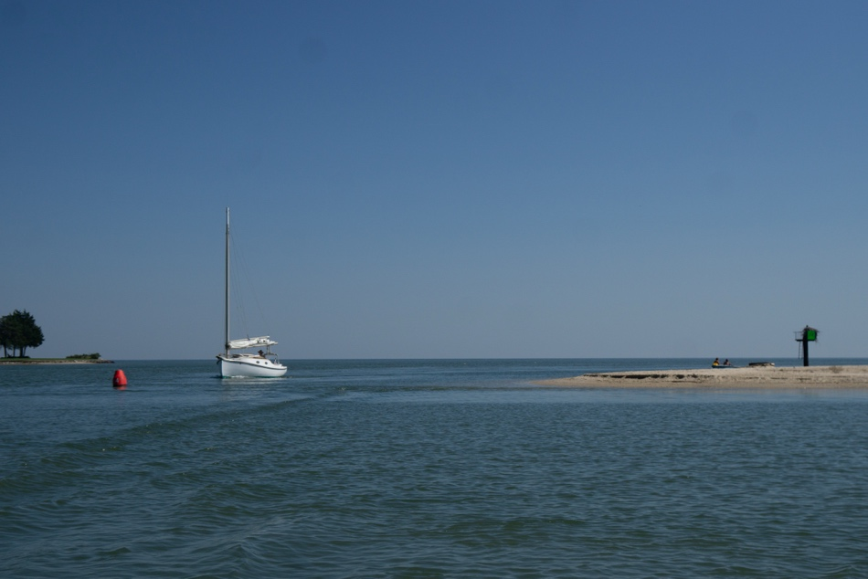
“Inside or outside?” - Phil Livingston

Marc: "Last time I sailed into St. Jerome Creek, it was a narrow switchback entrance with lots of current. This time the land on the northern side of the entrance was gone...eroded away. There was only a solitary red nun not much more than a boat width away from the sandy beach on the south side of the entrance. As I came up on the red under power but with the sail up, I hailed a local fishing nearby and asked if the red nun was in the "right place." The answer was: "pretty much." That did not instill confidence, but I left that red to starboard. As soon as I did, the local yelled: "Hard to Port....Hard to Port!" Without thinking I went hard to port and did not go aground as I picked up the next set of buoys into the cove where the catboats were. Lived to sail another day!"

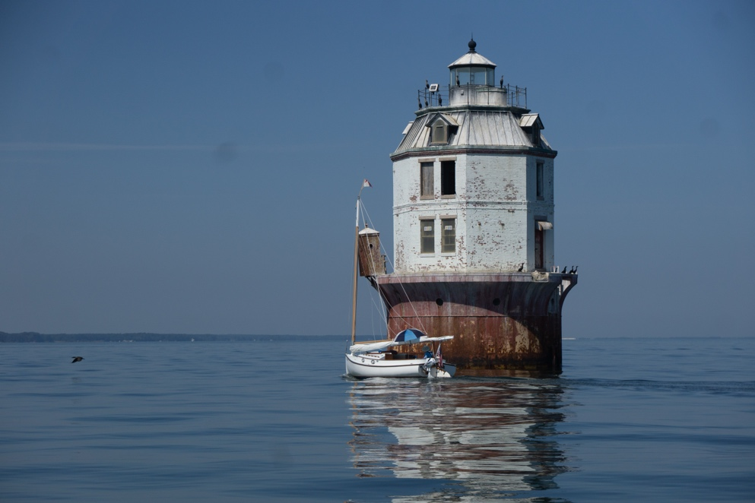
“Don’t look up”

Day 7 – Friday, Sept 20 - Back to Slaughter Creek, NE 30NM Cloudy ENE10 to E15++
All departed and took various courses up and across the bay around 8am. Curlew lost throttle control just outside the inlet and anchored. Seeing that, Marc went to offer help. Turns out that a screw holding the cable had come free and was quickly repaired. 10kt NE winds changed up E 15++ making for an interesting close hauled motor sail across the bay. Fortunately, when I reached the eastern shore the predicted shift to due east happened allowing me to head straight up the coast. Unfortunately, it brought the wind and seas onto the nose while trying to navigate the crab pots through the narrow pass over the bar that used to be James Island. Dropped sail as soon as I had made it through the pots and had room. I should have continued north around the mess then headed southeast. Arriving around 4pm, we all tied up to the pier of Palm Beach Willies, a casual Tiki Bar type place, for a well-deserved drink and dinner then anchored again in Chapel Cove with thankfully fewer skeeters.

Marc: "About 10 am while coming up close to the western shore from St, Jerome's, a school of small dolphins broke the surface and swam along with me close aboard and parallel to my course...close like I could have reached over the side and touched them. Was too engaged to catch it on the camera."

Day 8 – Sunday, Sept 21 Headed home. Mileage varies, 30NM for Lark. ENE 8-10-8 then 4 on the nose.
Having a long day ahead all raised anchor by 7am. Patriot and Lark headed for the fuel dock that was supposed to open at five. No dice as the self-serve pumps were kaput so we had to wait until 8 for the store to open. That morning was the best sail of the trip. Still had the reef in so it was smooth and easy making 4.5 to 5knt. I wanted to leave the reef in until I saw what the Choptank had in store. Turns out the wind was the same at its mouth, so the reef came out for a continued nice sail then the engine on at the tip of Tilghman island. The wind came on the nose after the turn northeast into Eastern Bay so eventually dropped sail at Lowe’s Wharf to putt-putt the rest of the way. It was a beautiful day with many sailboats headed home from St. Michael’s.

Our late summer trips usually bring a mixed bag of weather, but the Nor’easter added something special and made for some exciting passages and wet days. Lark covered about 230NM. Visiting Crisfield and Tangier was interesting and the highlights of the trip. We also enjoyed a couple our favorite anchorages in that area of the bay. Of course, the comradery among our fellow cruisers is always special.
“The Track”

