2013 Races & Events

Patuxent River Shootout - 2013
Solomons MD
Memorial Day Weekend
Calvert Marine Museum

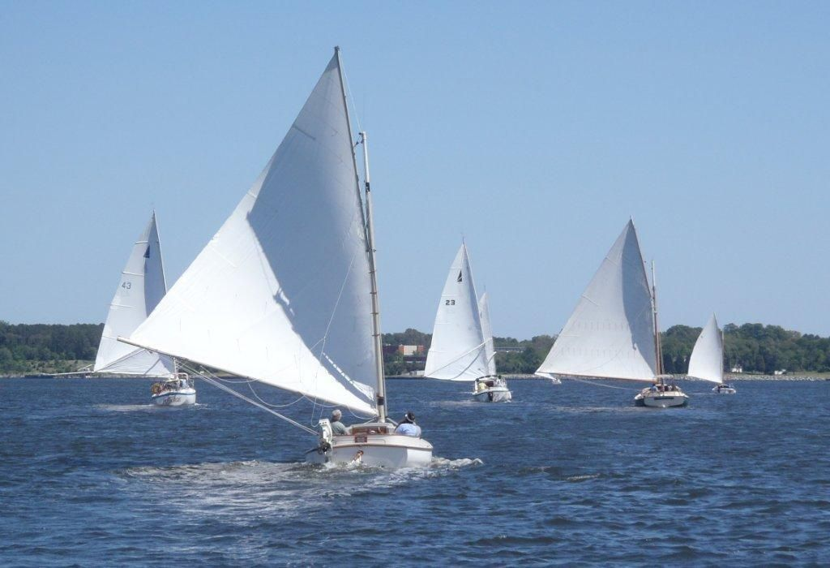

Patuxent River Shootout or 4-Sided vs. 3-Sided!
By Steve Flesner

The CCBA held the 8th Shootout over the Memorial Day weekend at the Calvert Marine Museum in Solomons Island, MD. The Friday before the weekend looked a bit foreboding with a strong front from the north blowing 30 knots with gusts up to 35 and temperatures in the low 60’s. As Butch Miller would say, ”it looked like a big boat trip,” and as it turned out, he was right! Pete McCrary took one look at the white caps on Friday afternoon, launched Tattoo, his 14’ Lightcraft in the river, notified the Coast Guard and made a successful, probably a bit wet, dash to the calmer waters inside Solomons one mile from the launch ramp. Marc Cruder and John Brown departed Annapolis (Ponder Cove) at 0530 in Wanderer on Saturday, double reefed, plenty of sail tape and with an outgoing tide. Wind at Thomas Point was 18 knots sustained with gusts to 25. They made hull speed+ and arrived at Drum Point in 5.5 hours making the museum’s boat basin a few hours later. Marc estimates they were making 7.5 knots “over the ground” possibly setting a new speed/distance record for Wanderer! The more prudent contingent of Marshal 18’s trailered in, Butch Miller - Dusty, Paul Cammaroto - Bubbly and Dave Morrow - Anna. The four Nonsuch guys Al Suydam - Rejoice, David Darmstadter - Blue Heron, Butch Garren - Whiskers and Tom Jones - Kit Kat, had their boats in the various marinas in Solomons so they just toodled over Sunday morning!

Saturday evening, guided by Butch Garren, 17 of us met for dinner at the Ruddy Duck, a local brew pub. Good food, good brews and great company!

So where does the 4 vs 3 come from? Marc suggested that it looked like a “Nonsuch invitational” given their fleet in Solomons; possibly one of the larger fleet of 22’s known to exist! Traditional catboats have four sided sails (Gaff Rig), Non-such guys have three sided (Sloop) and still believe the world is flat once you leave Solomons! Actually, this was really shaping up to be a unique opportunity to see just how the two types of catboats performed in what we described as lively conditions, 15 - 20 kts still blowing from the north with gusts over 25, but in the high 60’s. Al Suydam held the Captain’s meeting at 1100 and explained the course - similar to last year but starting at a mark on the far side of the river given the wind direction. The first leg would be to windward. Ken Spring and Ned Sprague would be on the committee boat reading and napping!

Given the fact that we had eight boats and many folks without boats, each Capt. screened his crew and all were accommodated who wanted to come on board. This year’s “ringer,” Katelin Wells, went with Paul and Andrea on Bubbly. Turns out she has an extensive catboat background and lived just down the road from Marshall Marine and used to ride her bicycle to the original Beetle shop and even wore a cap that said Padanaram, a dead give away! Bob and Gail McDonald from NC went with Kit Kat, Steve Flesner (cat-less) and Adam Hantman on Rejoice, Scott and Darcy were on Loveboat, aka Whiskers, Denise and Jennifer on Dusty, Matt and Noelle with dad along as crew on Wanderer (John Brown was given shore leave), Kim and Spencer on Anna, and Catherine and Cooper (their dog!) on Blue Heron.

The first race saw Anna first across the start line closely followed by Whiskers and Bubbly. Dusty decided to take a different approach and headed for the Eastern Shore but realized that since they could see no other catboats, returned post haste! The 2 ½ mile course was covered in a bit over an hour giving ample time for a second race. The wind had piped up during the last two legs of the first race so the Nonsuch guys tucked in a reef leaving the 4-siders under full sail. Once again Anna jumped into the lead followed by Whiskers and Wanderer who would soon be in their own close quarters battle with Wanderer coming up to only a few feet of Whiskers starboard quarter before having to back down before someone fainted! The remaining fleet had their own exchanges over the course but none could catch Anna who finished first in both races. Upon returning to the boat basin, all agreed it was two of the best Shootout races we have had and there were some interesting observations made concerning the 3-siders and the 4-siders. They mixed it up and neither dominated the other in overall performance.

After the trophies were given out, the lies resumed, some even related to the day’s races! The usual gourmet pot luck was held; smoked turkey breast, ham, NC barbeque, a polish sausage, egg and horseradish dish along with Chinese and Italian dishes, assorted salads and desserts; all non-fattening of course! Once the party wound down, a few of us met in Wanderer’s cockpit for a few more libations and to resolve what appeared to have been an error in calculation. Dusty finished well after Wanderer in both races so being the honorable thing to do; Butch Miller presented Matt Cruder with the third place trophy and asked for another dark and stormy. I apologize for not getting a picture of the presentation, but my camera wouldn’t focus! Bill Hoover would have been proud of the heritage he left behind, we do not protest races, we resolve, and then have a cocktail! Wanderer made it back to Ponder Cove on Monday evening after an 11-hour slog north, a bit slower trip then on Saturday.

My thanks go to Butch and Karen Garren, Al and Nan Suydam and of course Lois, my better half, for helping make this year’s Shootout such a success. As well as Ken Spring for again serving as the committee boat extraordinaire (it’s a classic wooden boat!). It’s always a lot of work, but it’s always a lot of fun!

“Official” Race Results from the Race Committee and corrected for Portsmouth ratings - corrected results follow:

Place Skipper Boat Model
1 Dave Morrow Anna Marshall 18
2 Paul Cammaroto Bubbly Marshall 18
3 Matt Cruder Wanderer Wittholz 25
4 Butch Miller Dusty Marshall 18
5 Butch Garren Whiskers Nonsuch 22
6 Al Suydam Rejoice Nonsuch 22
7 Tom Jones Kit Kat Nonsuch 22
8 David Darmstadter Blue Heron Nonsuch 22

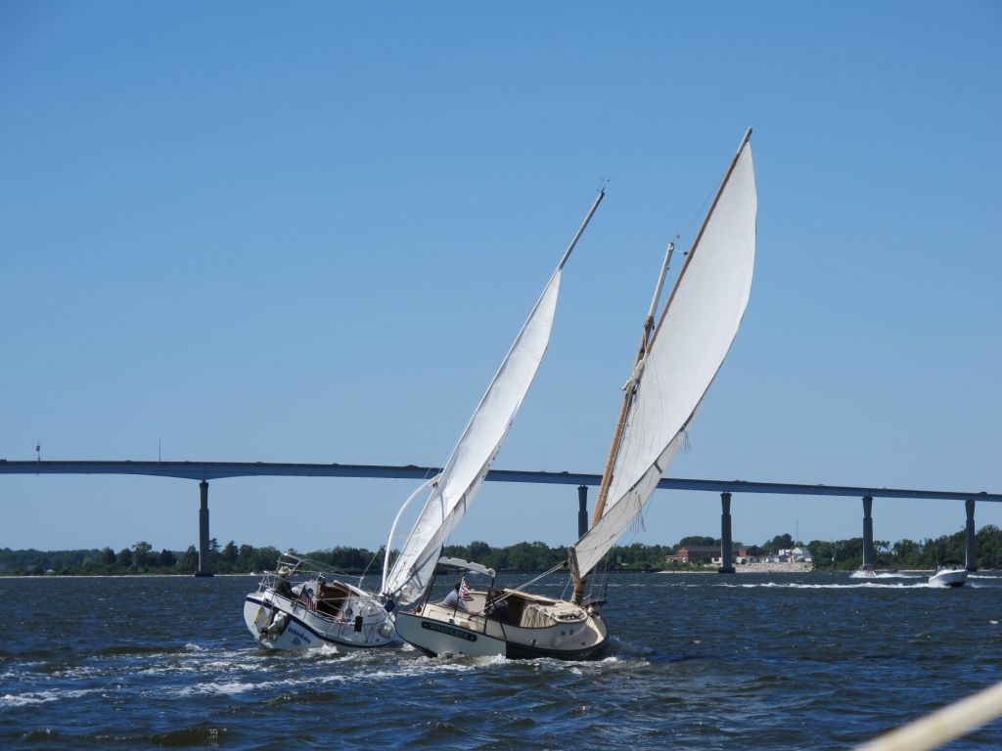

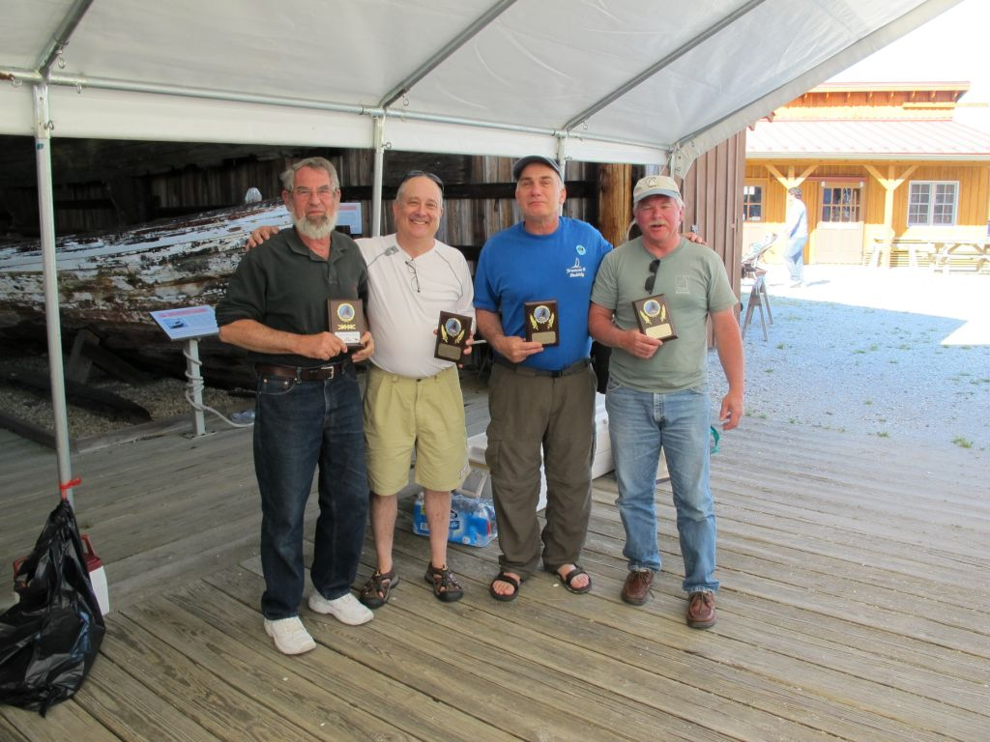

Race Committee Boat - Ken Spring
1 Dave Morrow
2 Paul Cammaroto
3 Matt Cruder (Dusty Miller standing in for Matt who later received the Plaque)

Corsica River Race
The Corsica River Yacht Club Annual Regatta
2013
Dave Bleil

The weather forecaster was not playing nice but the actual weather was not too bad for the weekend. Friday afternoon boats headed for the Rock Hall Yacht Club and an invitation from Richard McLaughlin, a member of RHYC and CCBA. The trip up to Langford Creek was mostly motoring. The Rock Hall Yacht Club featured a lively bar and suitable menu to an overflow crowd of members and guests. An increasing breeze straight up the river into the exposed anchorage of the RHYC left the Catboats rocking and rolling all night. Tenacity, Shoveller, Wanderer and Gull departed in the morning mists for the 900 hrs. skippers meeting at the home of the Corsica River Yacht Club. There was breakfast and hot coffee in the assembly hall. We all checked in and received our dinner ID tickets. The course was announced and cue sheets handed out. Dinghies were left at anchor and the Catboat fleet headed out, joined by Ben and Emma Heilman in their Marshall 15 Mephistopheles. Milling around us were 404's, Comets, Penguins, Windmills, and various configurations of
Lasers. Classes were started according to class flags flown from the committee boat. Conditions were becoming boisterous so Gull tucked in a reef. The NOAA weather radio was calling for severe thunder storms that evening or next day. After experimenting with the course and anticipating the wind to increase, Gull tucked in a second reef. Big mistake. The wind not only did not increase but also instead subsided a bit. After the first race the reefs came out. Three races were sailed on Saturday with Dusty and Mephistopheles dueling it out for first place, often side by side. Late afternoon had the fleet returning along with the larger boats from the cross Bay race. The beer truck was open for business and the barbeques were roasting chickens for the evening's feast. The traditional Bluegrass Band, now known as the Chester River Runoff, was entertaining the crowd. A well-fed crew turned in that night listening to the weather forecast of severe weather in the morning. In spite of the forecast, the night was calm but the mood was nervous in the morning. Because of the long trip home coupled with the probability of severe weather on the way, Wanderer and Tattoo elected to skip the Sunday races and head home after coffee and donuts. The CRYC Race committee was nervously rearranging the sailing course to the inside of the Corsica River so that the smaller boats would have only a short distance to safety. This resulted in a twice around triangular course crosswise to the river current. With all classes of boats on the same course there was a lot of traffic to keep track of. Anticipating a probable bailout and head home part way through the race Gull towed her dinghy to the course and left it anchored in the shallows out of the way (once we had figured where out-of-the-way was). The forecast bad weather did arrive late Sunday afternoon catching Wanderer, Dusty and Gull on route but close to home. The rain was heavy but the storm was not nearly as bad as others, which have followed previous CRYC Regattas.

Official final results of the 4 race series -
Place Skipper Boat Model
1 Ben & Emma Heilman Mephistopheles Marshall 15
2 Butch Miller Dusty Marshall 18
3 Ohlmacher & Bleil Gull Mystic 20+
4 Richard McLaughlin Tenacity Marshall 22
5 Michael Crawford Shoveller Fenwick Williams 25
6 Marc Cruder Wanderer Wittholz 25
DNF Peter McCrary Tattoo Chesapeake Lightcraft 14
The Great Whitehall Bay Catboat Race & Rendezvous – 2013
Butch Miller

The twenty-third annual Great Whitehall Bay Catboat Race & Rendezvous was held Sunday September 1, 2013 at the Providence Yacht Club in Annapolis Md. Begun by the late Capt. Bill Hoover on his home waters in Annapolis MD, this event is traditionally the CCBA’s most popular of the season. Carolyn, Bill’s first mate, has strived to continue the tradition by graciously hosting the event since his passing in 2005.
New to the event and racing this year were Denny Byrne and Nancy Ward sailing Gratitude, and Peter McAliney sailing Zeta Marie with the experienced Dave Park. Rounding out the fleet were Paul Cammaroto and Andrea sailing Bubbly, Dave Morrow and first mate Kim sailing Anna, Butch Miller sailing Dusty, Marc Cruder and Steve Flesner sailing Wanderer. A favorable weather forecast brought back David Bleil sailing Gull, who wisely shied away last year due to predicted storms for the return trip.
After last year’s drifter all welcomed the fairly steady 10kt winds out of the south into the open mouth of the bay that made for one of the best days of sailing we’ve ever had at this event for the smaller boats.
Two races of: “around twice, up and back” were held. The race committee set the marks early so as to avoid a bit of pre-race stress. Great idea but upon returning to the course it was found that the wind had shifted about ninety degrees. After a scramble to shift the marks, the route was changed and all was well for a start. Not! A call went out about grounding at the pin end. !@#!@#$%. So much for stress-avoidance.
After clean start in both races, it was as pretty much “ducks in a row,” and as expected Anna (pass the glasses so I can find her) took the lead, followed by Bubbly, Gull, Gratitude, Dusty, Wanderer and Zeta Marie. There were a few passes and crossings, but for the most part the boats finished in that order. Congratulations go out to Gratitude for challenging Gull most of the day as it was their first time racing this year. Wanderer was challenged by the lack of gale warning and the starts and the grass on the other side of the fence challenged Dusty.
Carolyn’s Mars and Tonic Bar was opened following the race setting the mood for the award ceremony where the Capt. Bill Hoover Perpetual Trophy, a mounted Mystic 20 half-hull donated by Peter Legnos, was presented to Anna for their first place finish. Cups were presented to Bubbly for second and to Gull for third place.
Many thanks to Carolyn Hoover for putting the event together once again and for the dedication and hard work she has put forth to continue the tradition of this special event. Also thanks to the Millers for co-hosting, and special thanks to Richard Rodgers and Jim Mohler for providing, and manning, the committee boat.
The Results:
Place Skipper Boat Design
1st Dave Morrow Anna Marshall 18
2nd Paul Cammaroto Bubbly Marshall 18
3rd David Bleil Gull Mystic 20
4th Butch Miller Dusty Marshall 18
5th Denny Byrne Gratitude Marshall 22
6th Marc Cruder Wanderer Wittholz 25
DNF Peter McAliney Zeta Marie Herreshoff 18
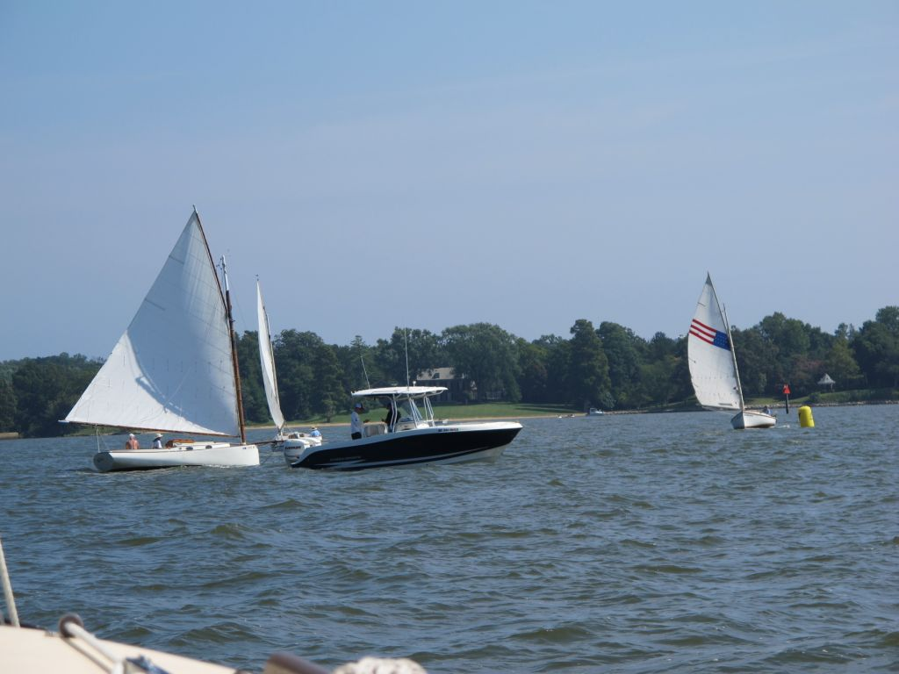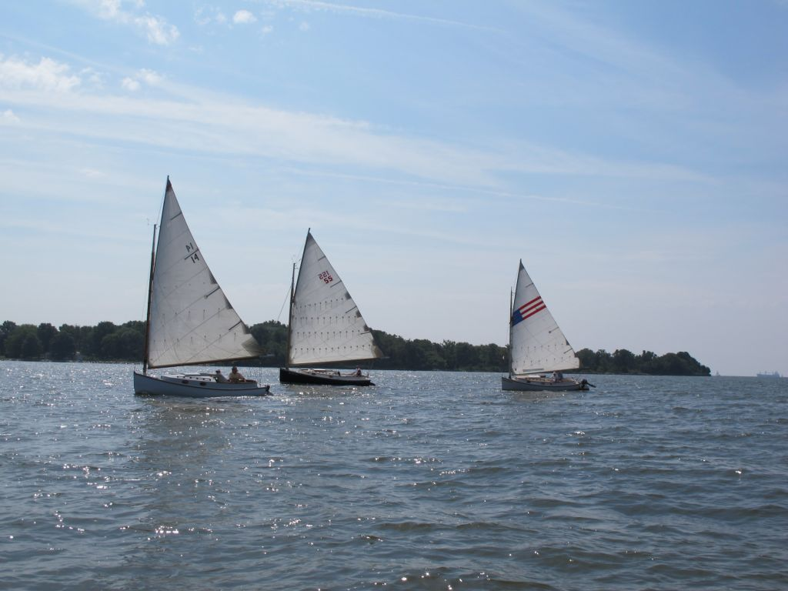
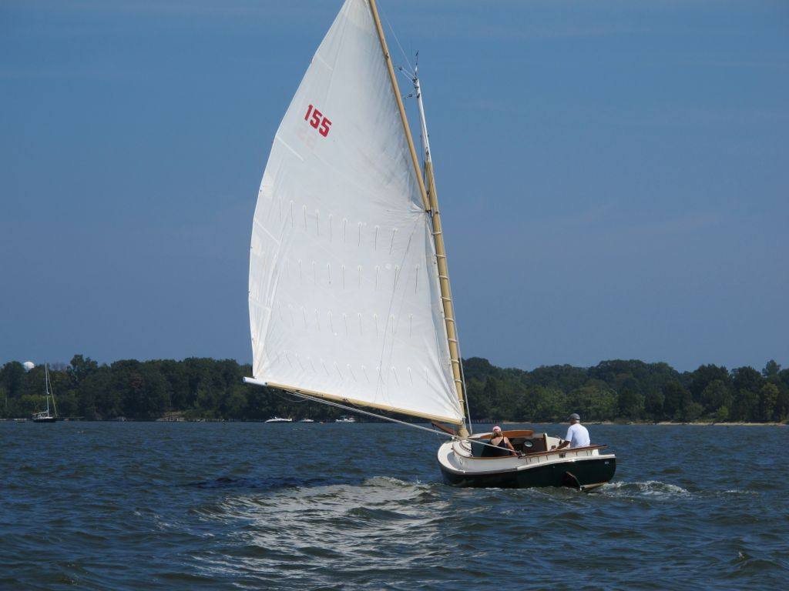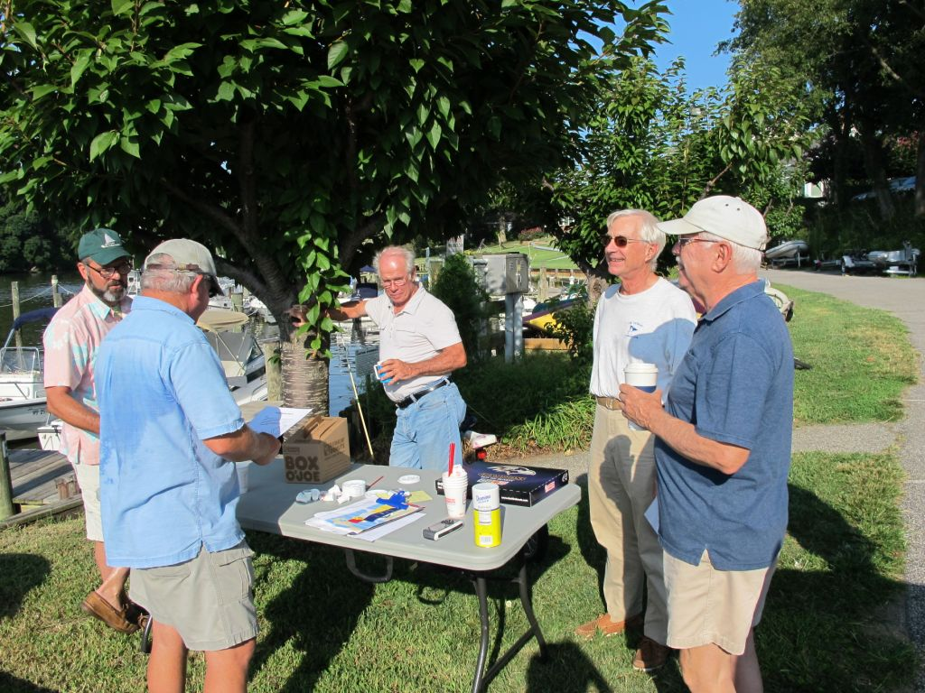
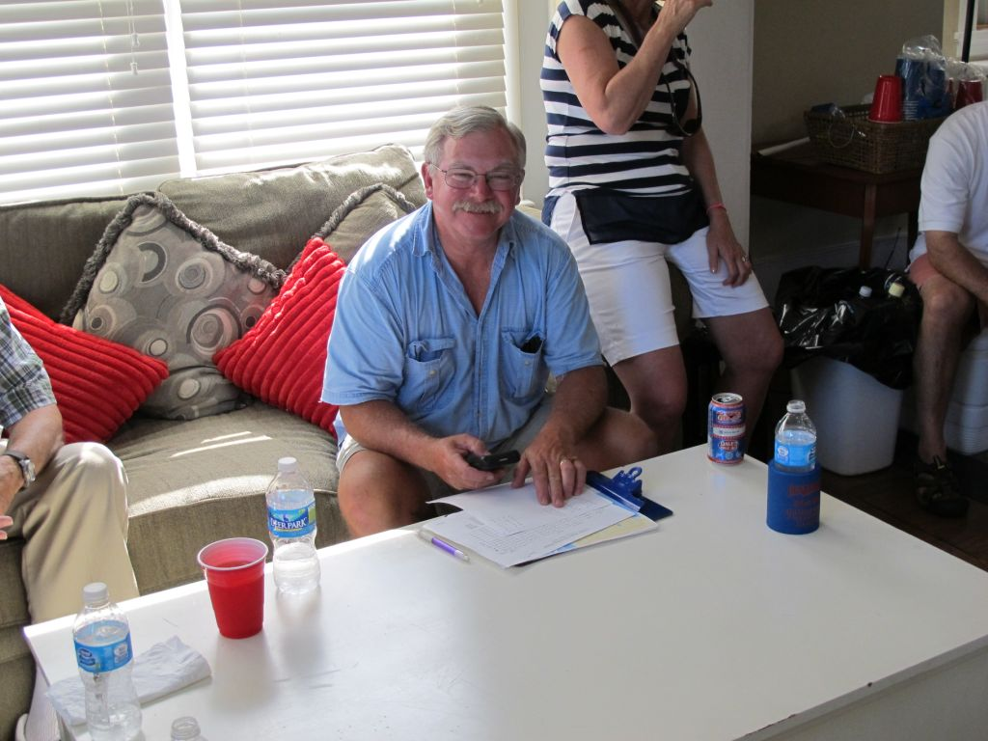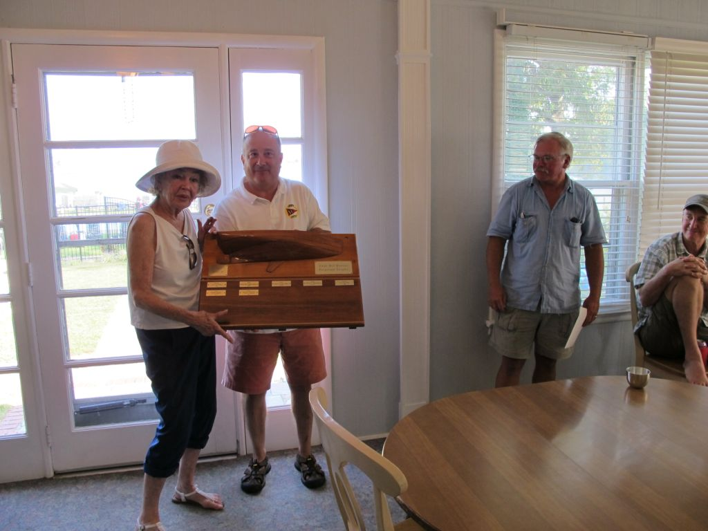

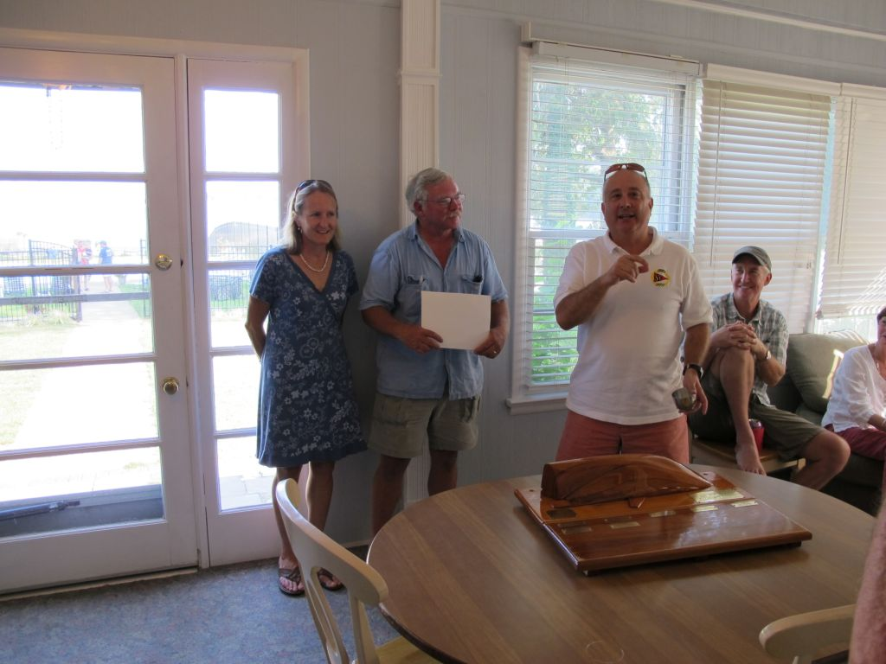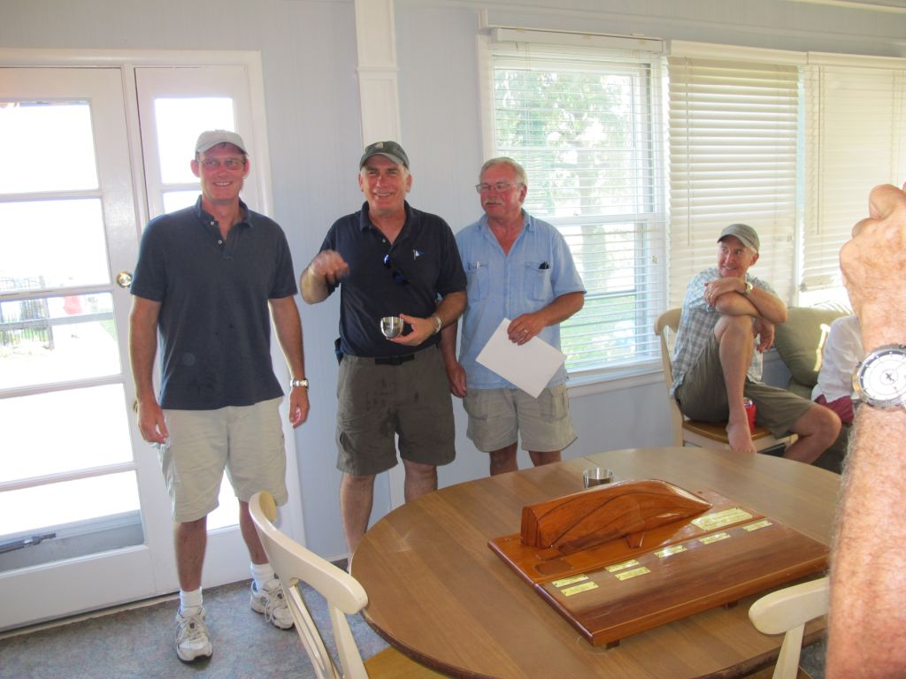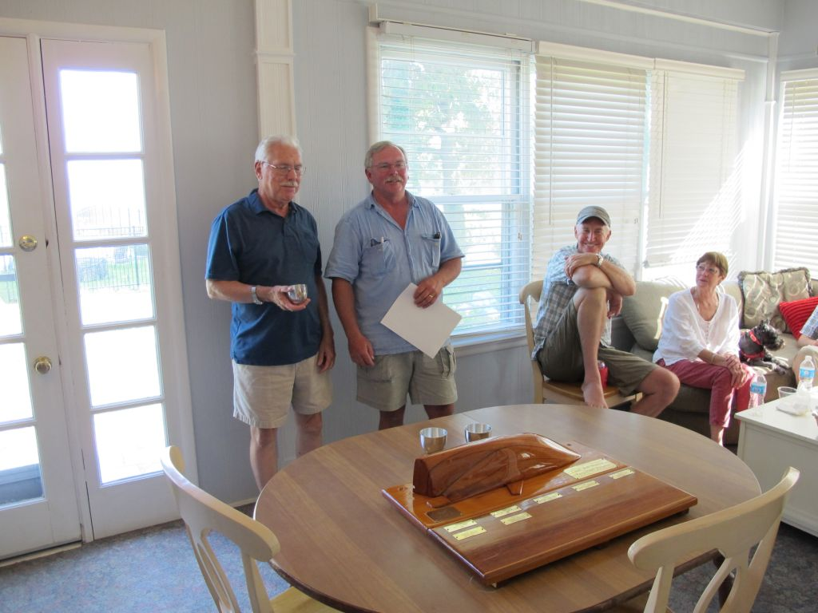

Prospect Bay Catboat Regatta
14 September 2013
Roger Compton

For the second consecutive year, a brisk northwest wind on a beautiful Saturday was the site of the 2013 PBCR. Five assorted catboats started an eight-leg race in various conditions of reefing. It was a genteel affair with no contacts and no protests. Using our locally developed Dunn/Hoover modified Portsmouth number handicapping algorithm, the results were as follows:

Place Skipper Boat Type Corrected Time
1 M. Cruder Wanderer Wittholtz 25 60.92 min
2 P. Cammaroto Bubbly Marshall 18 60.95 min
3 B. Miller Dusty Marshall 18 63.15 min
DNF D. Bleil Gull Legnos 20+ DNF
DNF D. Park Sarah K. Hereshoff 18 DNF

As the race committee was retrieving the race marks from the Bay, Rich McLaughlin arrived in Tenacity. Mistiming a drawbridge opening at Kent Narrows caused him to be listed as DNS for this year’s race.
Following the race, the competitors (and Rich) joined their fellow Chesapeake Bay catboaters at the home of Jill and Roger Compton for an evening of lively discussion (mostly catboat related), refreshments, and a potluck supper. The host and race committee chair awarded trophies for the 2013 PBCR.

There were four sanctioned race events on the Chesapeake Bay during the summer of 2013, the cumulative results of which resulted in the naming of the 16th Washington Irving (Tut) Tuttle Memorial Trophy winner. This year’s winner, by a similarly small margin over second place as in the above-reported results, was Butch Miller sailing Dusty.

