2012 Patuxent River Shootout
14200 Solomons Island Road Solomons, MD 20688
Patuxent River Shootout - 2012
Solomons MD
Memorial Day Weekend
Calvert Marine Museum's Lore Oyster House - on the Island!
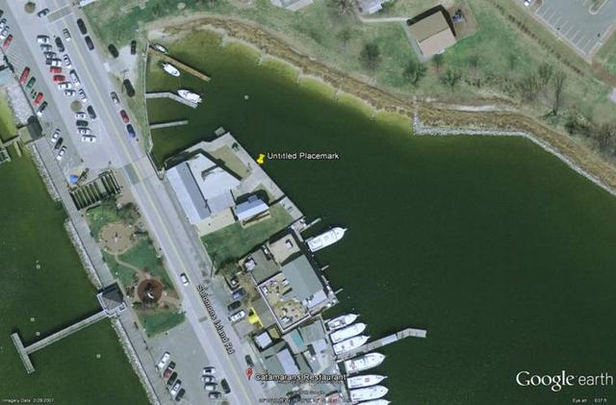The Chesapeake Catboat Association’s Patuxent River Shootout was held over the Memorial Day Weekend this year as a result of some venue conflicts - but as it turned out we had the best wind for the event in many years. The new date resulted in this being our first event of the season. It was held at the J. C. Lore Oyster House (on Solomons Island), which is owned by the Calvert Marine Museum. Adjacent to Stoney’s Kingfisher restaurant, its history can be found on the Museum's Web Site http://www.calvertmarinemuseum.com/exhibits/lore-oyster-house.php. There was plenty of dock space with deep water for catboats and a potluck was held right after the race.
The 27 May Race was around a 3.3 mile triangular course off Solomons Island in the Patuxent River saw six catboats ranging in size from a 14ft Compass Classic to a 25’ Wittholtz. The weather was just about perfect with a bright sunny day and 10–15 knots of wind from the South off the Solomons Boardwalk. Two races were planned and sailed (combined times for the final result) using the Portsmouth Handicap to equalize the racers (or attempted to do so). Most of the boats had guest crew aboard, which gave them a great look at how a catboat sails in a good wind. Both races had that, the second especially, so as Marc Cruder on his 25’ Wittholtz “Wanderer” took line honors for the two race series.

Ken Spring provided his wooden MacKenzie Cuttyhunk 26 Carole Anne as the committee boat with Al Suydam on board calling the races and providing the results to Butler Smythe who crunched the numbers from home as he recovered from recent surgery. Passing the results by cell phone and crunching the numbers using an automated Excel file saved time and allowed Ken and Al to concentrate on the boat and those around them as well as feast without having to worry about the results. Once safely ashore for the Pot Luck with a crowd of about 30 from as far away as North Carolina, the trophies for the first three positions were awarded as identified below.
Place Skipper - Boat - Design
1 Marc Cruder - Wanderer - Wittholz 25
2 Dave Bleil - Gull - Mystic 20
3 Brenda Clark - Scotty - Marshall 15
4 Butch Garren - Whiskers - Nonsuch 22
5 Butch Miller - Dusty - Marshall 18
6 Tom Jones - Tom Cat - Classic Cat 14

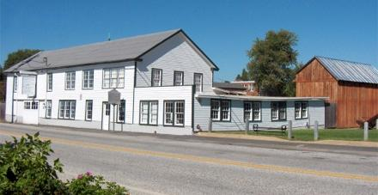
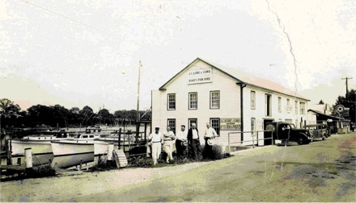

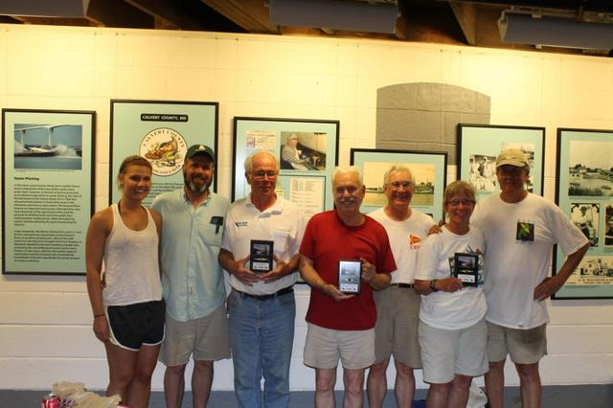
Noele Cruder, Marc Cruder, John Brown, Jim Ohlmacher, Dave Bleil, Brenda Clark & Steve Flesner
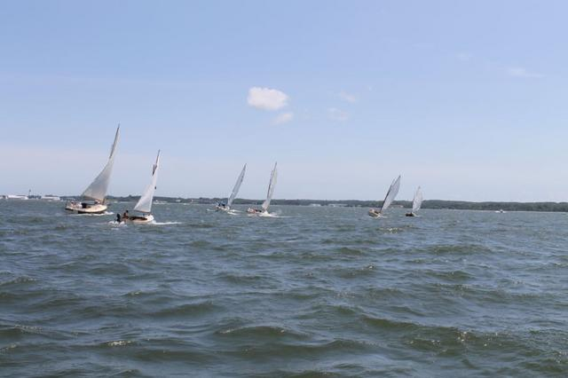
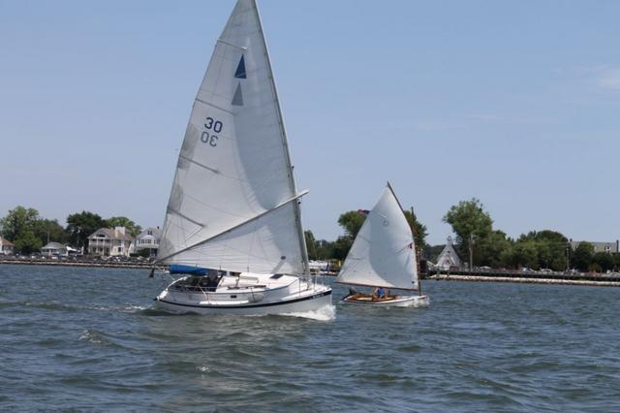
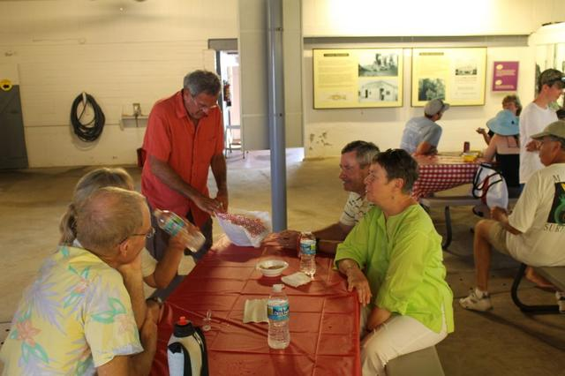
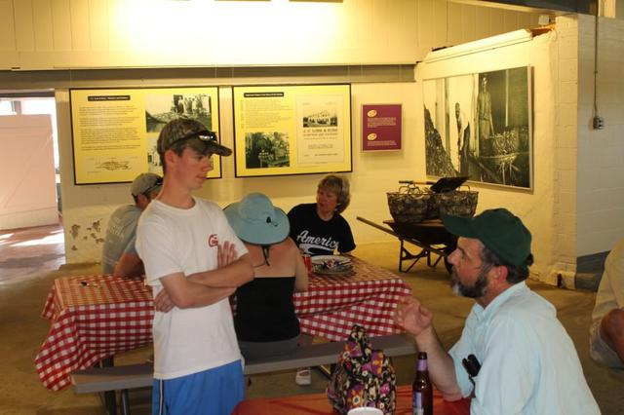
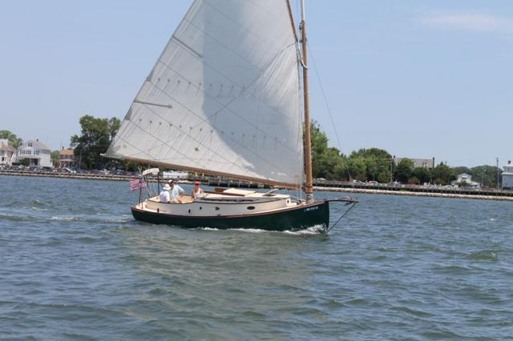
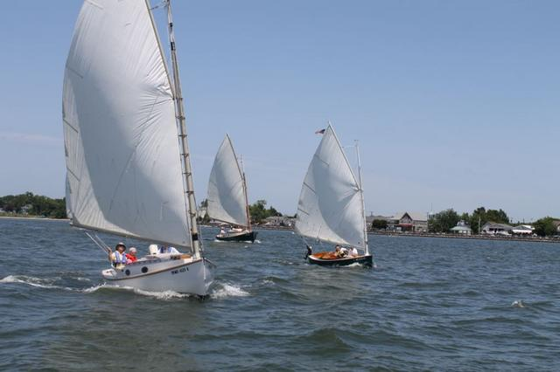
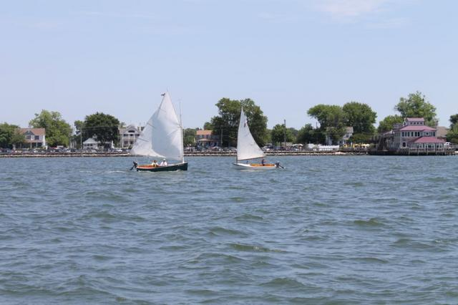
See MORE Photos at: http://chesapeakecatboatsorg.shutterfly.com/ By Butch Garren
Corsica River Race
Catboat Comedy at Corsica
The Corsica River Yacht Club Annual Regatta
July 28-29 2012
Dave Bleil
This year's event seemed to have the same excessive heat pattern as last year. Several boats and crew stopped Friday night at the Rock Hall Yacht Club as guests of Richard McLaughlin where they enjoyed showers, air-conditioning, Dark & Stormies and dinner at the bar. Don Dunn came by to wish us well and hoist a few. Wanderer, Dusty and Gull spent the night at the pier while Shoveller and Tenacity spent the night on a mooring. Next morning the fleet sailed across the Chester to the Corsica River and anchored off the Corsica River Yacht Club (CRYC) property. The landing was not as accessible as Conquest Beach, but there was launch service frequently available to transport sailors without dinghies to and from shore. At the registration and skippers meeting the course for the two days of racing was handed out and explained, and some explaining was needed for those of us in the catboat class. The CRYC Annual Regatta consists of races for many classes of boats, from kids in Optimist prams and Lasers to adults in Beach Catamarans, Comets, Penguins others. All of these are smaller, lighter and more maneuverable than Catboats, which presents a serious challenge to those setting up the racecourses to create courses, which are safe, and interference free for competing classes. The youngsters and the smallest boats has courses inside the Corsica River while the larger boats raced out in the Chester River at the intersection of several substantial tributaries. The course we sailed had a windward start, a reach across a stretch of two buoys, a down wind run and a windward return to the finish line. Between each set of races the distance between the marks was adjusted to compensate for changes in the wind speed. Just because you had sailed the course did not necessarily mean you knew where to look for the buoys the next time around.
The start was also a bit more complex than we are used to. The class flag was run up to show which class was next to start. Then a Blue “P” flag was hoisted on a stick. When that was dropped there was one minute to the start. When the class flag dropped we started. The one-minute interval seemed to vary by as much as 20 seconds by my watch. On the first race Gull was so confused that we had to sail by the committee boat and ask if we had started (we had). Over the course of several races we got better at this 2-flag start. Approaching the finish line in hot pursuit of Dusty, Gull was thrown off by a series of wakes (in the calm air) and spent three frustrating tacks to get back to the line and across it. A later race had Dusty heading for where the turning buoy used to be - before it had been moved - but Butch and Denise made a fast recovery, rounded the mark and finished first again. Dusty finished first every race and no one else could come close. The Cal 25's raced from Baltimore to Corsica Saturday and then back again Sunday. They arrived in time for the traditional Barbecued Chicken dinner, beer truck and bluegrass music by a local band whose new name has deserted my memory bank. The Cal sailors are a partying crowd and rafted up 6 boats across near the club pier with a light anchor out from the boats at each end of the raft. A lot of boat-to-boat visiting was occurring when the cloudy skies to the south opened up with a serious display of lightning. Those of us in the anchorage area adjusted our scope or set out more anchors. The wind arrived and the Cal raft traversed the anchorage in a spectacular drag. Others were out fending them off and trying to untangle fouled anchors. When the storm finally abated the Cats were a lot closer to Centerville, with their anchors apparently well set. On the last race Sunday it looked like the fleet finally had the start sequence figured out, except for Gull. Three boats in parallel on Starboard tack approached the line closely packed when Wanderer approached on Port tack and luffed the rest of the line so high that Dusty lost steerage and was carried by the current broadside onto Shoveller's bow. Fortunately none of the damage was serious and each boat, once untangled, continued on with the race. Wanderer parlayed her advantage at the start into a second place finish, but Dusty, in spite of everything, was over first. Gull being out of position for the start was able to avoid the traffic jam on the line and went on to finish third.
The overall standings after two days of racing were:
1st Dusty – Butch & Denise Miller, Marshall Sanderling
2nd Gull – David Bleil & Jim Ohlmacher, Mystic 20
3rd Wanderer – Marc Cruder & John Brown, Wittholz
4th Shoveller – Mike & Tristan Crawford, Fenwick Williams 25' 2”
5th Tenacity – Rich McLaughlin, Marshall 22

The awards ceremony took place about 2 PM. Marc and John had farther to travel so they headed home directly from the finish line of the last race. Mike Crawford kindly accepted Wanderer's trophy to transfer later. The rest of the fleet took advantage of the beer and lunch at the ceremony before heading home. We thanked the CRYC for allowing us to participate in this fun event and one of our burgees was presented to the Commodore to add to their collection. If you missed it you missed a good time.
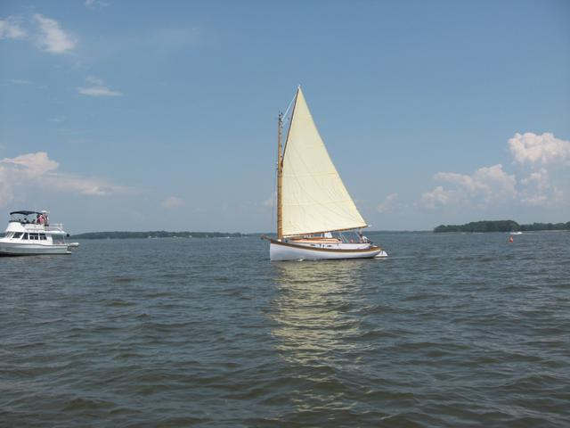
The Great Whitehall Bay Catboat Race & Rendezvous – 2012
- Butch Miller
The twenty-second annual Great Whitehall Bay Catboat Race & Rendezvous was held Sunday September 2, 2012 at the Providence Yacht Club in Annapolis Md. Begun by the late Capt. Bill Hoover on his home waters in Annapolis MD, this event is traditionally the CCBA’s most popular of the season. Caroline, Bill’s first mate has strived to continue the tradition by graciously hosting the event since his passing in 2005.
Paul Cammaroto and Andrea sailing Bubbly made their first appearance this year. Returning after a few years off to raise the kids were Dave Morrow and first mate Kim with Anna. Rounding out the fleet were Craig Ligibel and his Florida ringers on Mystic Wind, Dave Park in Sarah K, Butch Miller with crew, Wavy Davy Adamusko sailing Dusty, Richard Rogers and ringer daughter Jessica aboard Paws, Arey’s Pond 14; and Marc Cruder with seaman John Brown in , Wanderer. Unfortunately, Caerulean III and Gull dropped out on short notice with reasonable excuses but there are suspicions that the impending thunderstorms predicted for the sail home may have had an influence. As it turns out, predictions were on target and Dusty and Sarah K. were stirred but not shaken en-route.
The weather on race day was nowhere to be found. After a short delay, the drifter was started. All but Dusty and Wanderer managed to cross the line crawl for a hundred yards or so before the real drift began. For nearly an hour all attempted in vain to move forward but managed only to slow their progress backward toward the starting line. After fifty-eight minutes, Dusty crossed the line and Anna was well past the first mark with a few others in loose pursuit. And so it went. With an average speed of about a knot and a half over the short course, Anna crossed the line after lapping every contender in the fleet at least once and once again we needed the glasses to read her stern. However, the handicap took its toll and much to Anna’s dismay and everyone’s surprise, little Paws won the day with Anna taking second and Bubbly third.
Overheard:
Around the start line,
From the committee boat, “Did you put the date on the trophies?” Reply, “Yup. The wind will come”
The sound of a pop top then “It’s noon, Dark and Stormy anyone?”
To a sullen, over focused skipper, “Can we talk now?”
“Damn, the beer’s gone and we haven’t crossed the line”
“I’m done”
“Pull up the board, we’re aground”
On the cell from shore side,
“What &*#$ are you guys doing out there? The food’s getting cold”

Caroline’s Mars and Tonic Bar was opened following the race setting the mood for the award ceremony where the Capt. Bill Hoover Perpetual Trophy, a mounted Mystic 20 half-hull donated by Peter Legnos was presented to Richard Rogers and crew Jessica for first place. Cups were presented to the Anna’s Dave Morrow and first mate Kim for second place and to the Bubbly’s, Paul Cammoroto and Andrea for third.

Many thanks to Caroline Hoover putting the event together once again and for the dedication and hard work she has put forth to continue the tradition of this special event. Also, thanks to the Millers for co-hosting and special thanks to Roger and Jill Compton for their fine work and never ending patience manning the committee boat.

The Results:
Place Skipper - Boat - Design
1st Richard Rodgers - Paws - Arey’s Pond 14
2nd Dave Morrow - Anna - Marshall 18
3rd Paul Cammoroto - Bubbly - Mystic 20
4th Craig Ligibel - Mystic Wind - Mystic 20
5th Butch Miller - Dusty - Marshall 18
6th Marc Cruder - Wanderer - Wittholz 25
DNS Dave Park - Sarah K - Herreshoff 18

Prospect Bay Catboat Regatta
15 September 2012
- Roger Compton
With a brisk northwest wind on a beautiful Saturday, six assorted catboats started an eight-leg race in various conditions of reefing. By the time it was over, most had shaken out their reefs as the wind weakened steadily throughout the afternoon. It was a genteel affair with no contacts and no protests. Using our locally developed Dunn/ Hoover modified Portsmouth number handicapping algorithm, the results were as follows:
Place Skipper - Boat - Design
1 P. Cammaroto - Bubbly - Marshall 18
2 M. Cruder - Wanderer - Wittholtz 25
3 J. Ohmacher - PussyFoot’n’ - Legnos 20
4 B. Miller - Dusty - Marshall 18
5 D. Bleil - Gull - Legnos 20+
DNF D. Park - Sarah K. - Herreshoff 18

Following the race, the competitors joined their fellow Chesapeake Bay catboaters at the home of Jill and Roger Compton for an evening of lively discussion (mostly catboat related), refreshments, and a potluck supper. Trophies for the 2012 PBCR were awarded by the host (and race committee chair) as the sun set in the west.
There were 4 sanctioned race events on the Chesapeake Bay during the summer of 2012, the cumulative results of which resulted in the naming the Washington Irving (Tut) Tuttle Memorial Trophy winner. Once again the winner was Commodore (without portfolio) Marc Cruder.

