2010 Races & Events
CCBA Annual Meeting
6 March 2010
Severn Inn Annapolis MD

The Chesapeake Catboat Association met 6 March 2010 at the Severn Inn for their Annual meeting, which was well attended by both old and new members. People came from all over the Chesapeake area came to hear what was in store for the new season, as well as renew old and initiate new friendships.
With displays, slideshows, catboat related books as well as photos of events past presented for all to see the, the event successfully identified what we hope will be the best season for the organization. The organization has also gained two new members who have brought their Nonsuch 22 sailboats into the fold, and another member (Steve Flesner) recognized by the national catboat organization for his service to the CBA. During the meeting his wife Lois was specifically recognized by our Commodore (Marc Cruder) for her ability to put up with our Roving Ambassador’s treks in search of catboats, catboat builders and those that associate themselves with these unique craft of the bay. How many 17’ sailboats are taken on weeklong (+) cruises of the bay? Not many.

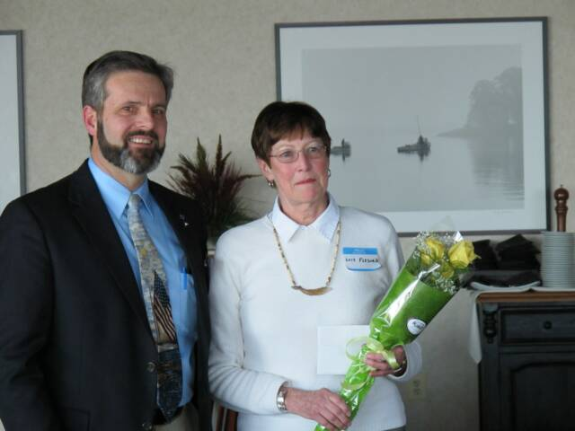
2010 Paxtuxent River Shootout

The Chesapeake Catboat Association’s Patuxent River Shootout was held over the July 4th weekend using the Calvert Marine Museum as the venue for the weekend’s successful activities for the first time. Their willingness to host our diverse group was much appreciated and the public got to see and hear about our boats as well. We mustered a record 10 boats that included a Handicat 14 up to the massive 25’ wooden Shoveller. Most boats arrived the 3rd, with races and potluck dinner – followed by fireworks – on the 4th. The race this year did have some wind, thought not steady through the race and it was called as most of the boats drifted in the current after only one lap of the course across the Patuxent River, with the Solomon’s boardwalk a great place to see the start. Battling shifting light winds, current and the ever-present powerboats that made tacking in the light winds all but impossible, Butch Garren on his Nonsuch 22 won the day. Dave Bleil in his Mystic 20 and the other Butch (Miller) in his Marshall 18 followed. The rest of the boats are listed in either engine ON sequence, or an estimate of where they were relative to the “finish” mark when the race was called. Another interesting wind even that perplexed the organizers for venue to support wind, the course and avoid the ever-present powerboats and jet skis that we can’t seem to avoid. Our thanks to Kent Mountford for supplying the last minute RC boat as well.

The Results:
Place Skipper Boat Design
1 Butch Garren No Name Nonsuch 22
2 Dave Bleil Gull Mystic 20
3 Butch Miller Dusty Marshall 18
4 Mike Crawford Shoveller Fenwick Williams 25
5 Glenn Hall Time Herreshoff America 18
DNF Marc Cruder Wanderer Wittholtz 25
DNF Butler Smythe Caerulean III Menger 23
DNF Steve Flesner Scotty Marshall 15
DNF Deborah Kerr Patience Handicat 14
DNS Alan Suydam No Name Nonsuch 22

